PRESS RELEASE
COMMUNICATIONS AND MEDIA TEAM OF THE 43RD ASEAN SUMMIT 2023
No. 62/SP/TKM-ASEAN2023/ENG/9/2023

43rd ASEAN Summit: Momentum to Combat Hoaxes and Disinformation
Jakarta, 4 September 2023 – The 43rd ASEAN Summit in Jakarta serves as a good momentum to combat misinformation (hoaxes), fake news, and disinformation that is becoming more widespread with the increasing use of the internet in the Southeast Asian region.
This was a statement from the Deputy Minister of Communications and Informatics Nezar Patria at the Media Center for the 43rd ASEAN Summit in Jakarta on Monday (4 September 2023).
“I believe that the 43rd ASEAN Summit is a good momentum within the framework of cooperation of ASEAN member states to combat all of those, and there are also the ASEAN Task Force on Fake News and the ASEAN Newsroom. These are part of information sector cooperation, a part of the ASEAN Digital Masterplan 2025,” said Nezar Patria.
According to him, the momentum of the ASEAN Summit in Jakarta can serve as a forum to share experiences in government information management among ASEAN member states, particularly in dealing with fake news.
This is because internet usage in the Southeast Asian region has increased rapidly in recent years and is predicted to continue its surge in the next three years.
“With the abundance of information circulating on the internet, there is a need for an effort to educate the ASEAN community, especially in dealing with fake news and disinformation,” he said.
Indonesia’s ASEAN Chairmanship in 2023 is considered to have a positive impact because it can bring up the topic of the ASEAN Digital Masterplan to be discussed at the ASEAN Summit on 5 – 7 September 2023.
“It has actually become a regional concern, especially as a result of the digital growth experienced by ASEAN countries,” said Patria.
The Deputy Minister also stated that the ASEAN Digital Masterplan 2025 aligns with this year’s ASEAN Chairmanship, “ASEAN Matters: Epicentrum of Growth”, considering the growing contribution of the digital economy in the region.
“I believe that the ASEAN community is increasingly exposed to the digital economy,” he stated.
In this regard, he emphasized two crucial aspects, namely managing the global supply chain for the digital economy and exchanging data related to autonomous mobility technology (self-driving cars).
According to him, these two aspects will be the focus of discussions at the ministerial meetings and the Senior Officials’ Meeting at the ASEAN Summit.
“This is certainly an anticipation for the future. Even though the use of driverless cars is not high yet, it should be anticipated. That is also a concern, as a form of the ASEAN community’s response to the current growth of digital technology,” said Deputy Minister of Communications and Informatics Nezar Patria.
(US/Elvira Inda Sari/Wisnu Wardoyo)

***
For more information, please contact:
Director General of Public Information and Communications of the Ministry of Communications and Informatics – Usman Kansong (0816785320).
Get more information at http://asean2023.id, https://infopublik.id/kategori/asean-2023, and https://indonesia.go.id/kategori/ragam-asean-2023

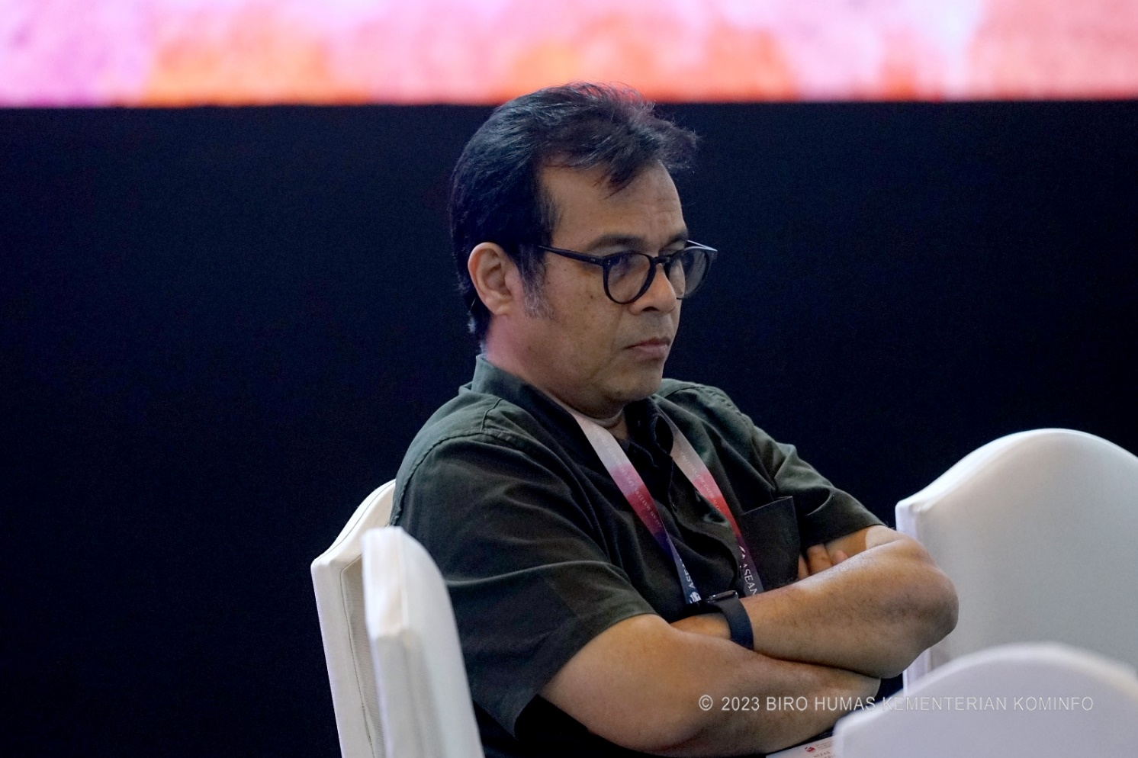
Deputy Minister of Communications and Informatics Nezar Patria sits in a chair at the Media Center for the 43rd ASEAN Summit in Jakarta on Monday (4 September 2023). The 43rd ASEAN Summit in Jakarta serves as a good momentum to combat misinformation (hoaxes), fake news, and disinformation that is becoming more widespread with the increasing use of the internet in the Southeast Asian region. (Pey HS/Public Relations Bureau of the Ministry of Communications and Informatics)

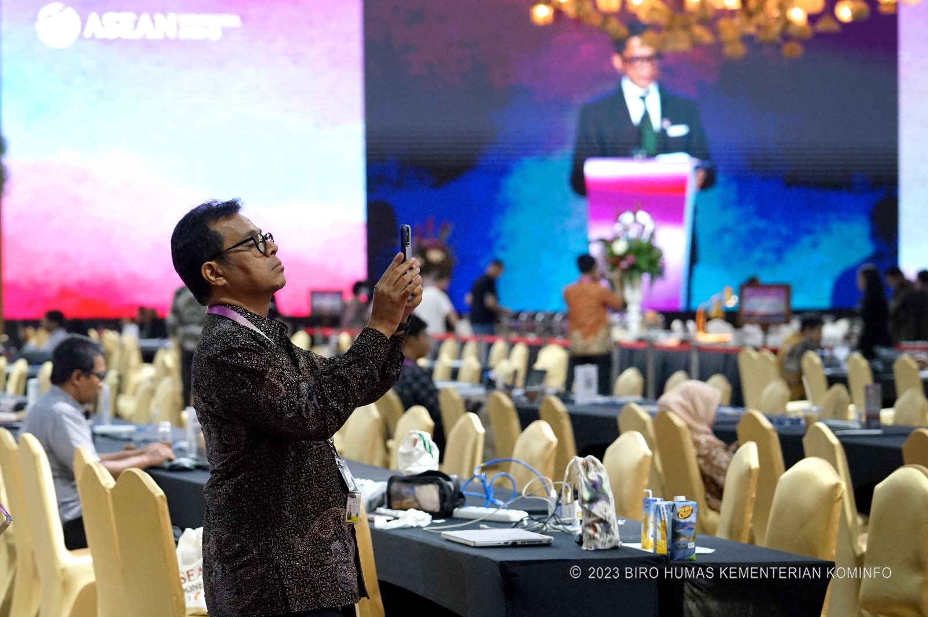

Deputy Minister of Communications and Informatics Nezar Patria takes a picture at the Media Center for the 43rd ASEAN Summit in Jakarta on Monday (4 September 2023). The 43rd ASEAN Summit in Jakarta serves as a good momentum to combat misinformation (hoaxes), fake news, and disinformation that is becoming more widespread with the increasing use of the internet in the Southeast Asian region. (Pey HS/Public Relations Bureau of the Ministry of Communications and Informatics)

